



**Assignment Brief – BTEC**

|  |  |  |  |  |  |
| --- | --- | --- | --- | --- | --- |
| **Programme** | | Level 3 Extended Diploma in Creative Media Production (Games Development) | | | |
| **Unit number(s) and title covered** | | Unit 4: Creative Media Production Management Project | | | |
| **Assignment number & title** | | Assignment Three : Production Project | | | |
| **Student name** | | *Lewis Hawkins* | | | |
| **Assessor** | | James Shaun | **Internal Verifier** | *David Matravers* | |
| **Date issued** | | *29/04/2019* | **Submission deadline** | *07/06/2019 at* ***4.30pm*** | |
| **Assessment Criteria** | **To achieve the criteria, the evidence must show that the student is able to:** | | | | **Assessor confirm met** |
| P3 | Manage a production process to create a media product working within appropriate conventions and with some assistance. | | | |  |
| M3 | Manage a production process competently to create a media product to a good technical standard, showing some imagination and with only occasional assistance. | | | |  |
| D3 | Manage a production process to near-professional standards to create a media product, showing creativity and flair and working independently to professional expectations. | | | |  |

|  |  |  |  |  |  |  |  |  |  |
| --- | --- | --- | --- | --- | --- | --- | --- | --- | --- |
| **Assessor feedback - 1st submission** | | | | | | | | | |
| *Task No* | *Targeted Criteria* | *Met* | *Comment* | | | | | | |
| 1 | P3 |  |  | | | | | | |
| 1 | M3 |  |
| 1 | D3 |  |
| **Did the learner meet the original deadline or agreed extension?** | | | | Yes ☐ No ☐ | | | | | |
| **Assessor signature** | | |  | | | | **Date** | |  |
| **Resubmission authorised?** | | | | Yes ☐ No ☐ | | | | | |
| **New agreed deadline date for submission** *\* must be within 10 days of receiving original assignment back* | | | |  | | | | | |
| **Lead Internal Verifier signature** | | |  | | | **Date** | |  | |
| **Assessor feedback - Resubmission** | | | | | | | | | |
|  | | | | | | | | | |
| **Assessor signature** (resubmission only) | | |  | | **Date** | | | |  |

|  |  |  |  |  |
| --- | --- | --- | --- | --- |
| **Scenario** | | | | |
| After months of developing projects, interning, and working for an array of small time developers including “Onslaught Games”, “PCPlayer” and “Insane EnterThainment” you have decided to branch out and start your own developer house.  After the concept dtages and now the presentation/pitch process is completed, you should now look forward to the production of your product and a functional, presentable, prototype.  You will now move onto the production and post-production stages for this product. You should start to document your progess and any deviations from the original plan. You should make sure to maintain communication with your team, and work together for a successful project launch. | | | | |
| **Tasks and criteria covered** | | | | |
| **Task 1**  You must now conduct the relevant stages to complete the production of a functional or fit for pupose prototype for your chosen concept.  You must ensure that you demonstare effective organisational skills and work with your team to maintain progress.  You may need to continue to develop your detailed planning, and you should also document the process you make clearly and effectively, this may be on a week by week basis, demonstrating the progress you make and the communication you have with your team.  Your final product should be fit for purpose and be an accurate proof of concept to your original plans which demonstrates that you have tackled the task with appropriate care, attention and application of skills. The outcome should be a product which, in technical and creative terms approaches a professional standard showing high level technical skills and confidence in the use of equipment.  Your hand in should include a final exported or completed project with documentation of planning meetings and what was said/agreed, as well as a working log of how the project is progress with you own input.  You may also want to consider the Bold headings below, and the subheadings for some guidance, note that you do not need to include evidence for all sub headings in your final submission     * **Planning*:*** *agreed production roles; job allocation; task definitions and deadlines; agreed content outline within proposal; preliminary and regular team meetings; agendas and minutes; proposed schedules; logistics, eg personnel, equipment, locations, additional facilities, additional resources; contingency, eg resources backup, logistics backup; time frame for project maturity; risk assessments* * **Production management:** *pre-production phase; production phase; post-production phase; project management techniques, eg spreadsheet, dedicated software, agile methods, scrums; team and individual performance; contingency plans for staffing and resources; monitoring and reviewing; problem solving; prioritisation; crisis management; quality control; meeting submission dates; modifications after completion* * **Product:** *technical and aesthetic qualities; realisation of proposal; fitness for purpose, eg audience, commissioning organisation or agency, client*   [Task Covers P3, M3, D3] | | | | |
| **Evidence you must produce for this task** | | | | |
| Planning and production portfolio  Final product | | | | |
| **Sources of information** | | | | |
| **Sources of information**  **Textbooks**  Baylis P, Freedman A, Procter N et al – BTEC Level 3 National Creative Media Production, Student Book  (Pearson, 2010) ISBN 978-1846906725  Baylis P, Freedman A, Procter N et al – BTEC Level 3 National Creative Media Production, Teaching Resource  Pack (Pearson, 2010) ISBN 978-1846907371  Chandler H – The Game Production Handbook (Charles River Media, 2006) ISBN 978-1934015407  DiZazzo R – Corporate Media Production, 2nd Edition (Focal Press, 2003) ISBN 978-0240805146  England E and Finney A – Managing Multimedia: Project Management for Web and Convergent Media, Book 1:  People and Processes, 3rd Edition (Addison Wesley, 2001) ISBN 978-0201728989  England E and Finney A – Managing Multimedia: Project Management for Web and Convergent Media, Book 2:  Technical Issues, 3rd Edition (Addison Wesley, 2001) ISBN 978-0321436931  Fraser P and Oram B – Teaching Digital Video Production (BFI Education, 2005) ISBN 978-0851709772  Hardy P – Filming on a Microbudget (Pocket Essentials, 2004) ISBN 978-1842433010  Kindem G and Musburger R – Introduction to Media Production: From Analog to Digital, 2nd Edition (Focal  Press, 2001) ISBN 978-0240804088  Laycock R – Audio Techniques for Television Production (Focal Press, 2006) ISBN 978-0240516462  Maciuba-Koppel D – The Web Writer’s Guide (Focal Press, 2002) ISBN 978-0240804811  Nisbett A – The Sound Studio: Audio Techniques for Radio, Television, Film and Recording, 7th Edition (Focal  Press, 2003) ISBN 978-0240519111  Oriebar J – Digital Television Production: A Handbook (Hodder Arnold, 2001) ISBN 978-0340763230  Roberts-Breslin J – Making Media: Foundations of Sound and Image Production (Focal Press, 2003)  ISBN 978-0240805023  Rudin R and Ibbotson T – An Introduction to Journalism: Essential Techniques and Background Knowledge (Focal  Press, 2003) ISBN 978-0240516349  **Websites**  https://trello.com/en **-** A Project Management and Workflow assistant  www.gamasutra.com – A sister publication to the print magazine Game Developer  www.skillset.org/interactive/careers/article_4754_1.asp – Skillset’s pages on the role of a project manager | | | | |
| **Student checklist** | | | | **Complete?** |
| Proofread work | | | |  |
| Reference / Bibliography (if applicable) | | | |  |
| All pages attached and numbered – including introduction/conclusion/front sheet | | | |  |
| **Authenticity of Evidence Student declaration** | | | | |
| I certify that the evidence submitted for this assignment is my own.  I have clearly referenced any sources used in the work.  I understand that false declaration of authenticity (i.e. plagiarised work) is a form of academic misconduct and the relevant College procedures will be instigated if I am found to be in contravention of these. | | | | |
| **Student signature** |  | **Date of submission** |  | |
| **Re-authentication of Evidence Student declaration (for resubmission only)** | | | | |
| **Student signature** |  | **Date of resubmission** |  | |

NB. Students – the assignment starts on the first page **after** these front sheets, i.e. Page 1.

* For your convenience, page numbers have been inserted into the footer. **Please keep them**.
* You may choose to add a contents table (ToC) in this section.
* Please **do** **not use text boxes** for the main body of your written answers.
* Please make sure that images/screenshots are correctly formatted, laid out and labelled. A table of Figures (ToF) may also be added if you wish.
* Make sure you use Page (or Section) Breaks whenever a new page is required. (Rather than adding large numbers of Return/Paragraph characters.) Ensure that new Section breaks continue with correct orientation and correct page numbers.
* Ensure that you have referenced your work throughout, using references in text and that you also have a reference list and full bibliography at the end of the work according to the current **Harvard Referencing** conventions. **Failure to do so will make your work more difficult to authenticate.**

**Task One:**

**Planning:**

**Job Allocation:**

For this project I will be working alone, so I will have to take on all roles to their fullest extent. Below is a list of roles I’ll fulfil with a short description:

Game Designer: Concept features / story / missions / etc and conclude how they should be implemented.

3D Modeller: Create UV unwrapped 3D models for concepting and game content.

3D Animator: Animate the 3D models to bring them to life.

Texturer: Texture the 3D models.

Graphic Artist: Create icons for the games content.

UI Designer: Design the user interface.

Programmer: Code the games features / missions / etc.

Sound Designer: Design and create/direct sound effects, music tracks and dialogue.

**Agreed Content:**

When concepting this game, I decided on a few core features I couldn’t change, and a few smaller features that could change.

Core Features:

* Looter-Shooter
* RPG
* Sci-Fi
* FPS
* Campaign
* Replayable mission structure.

Smaller Features:

* Rare weapons and armour.
* Multiple enemy races.
* Arcade mode.
* Free play (freeroam).
* Deep customization for gear.

**Production Log:**

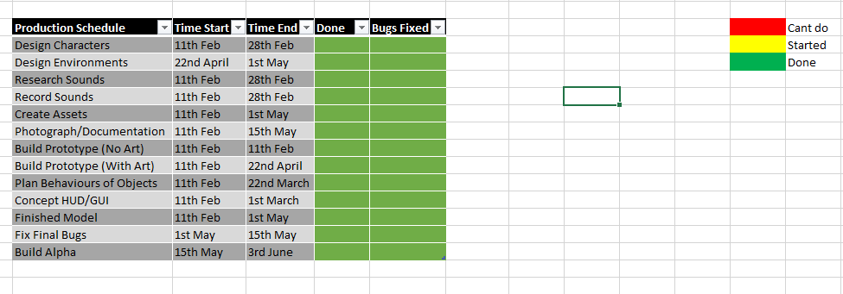

**Production Management:**

**Pre-production:** In this phase I designed some of the enemies and environments. Below are a few concepts:

The concept art for Fort Cavan:

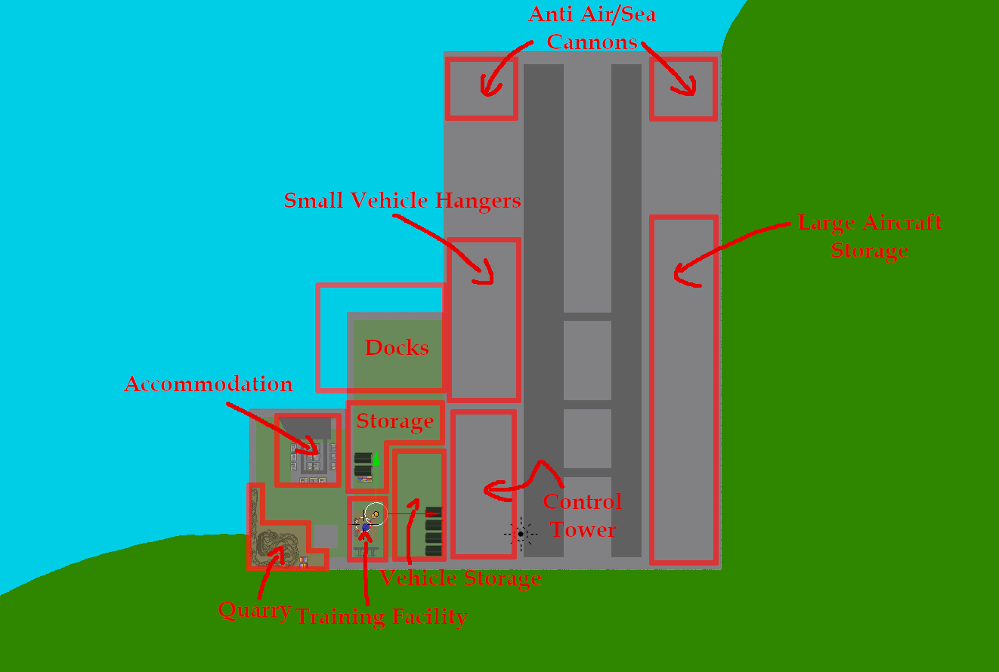

The concept art for the Akktane soldiers:

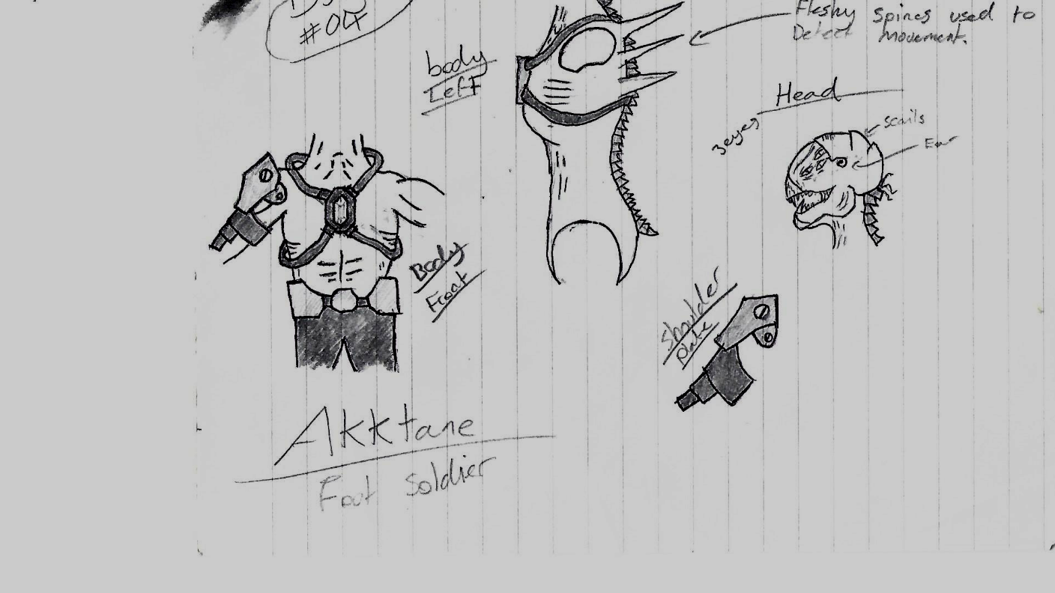

During the pre-production I must consider the possibility I won’t be able to complete all targets for the game, so i’m going to start with the basics and expand off that.

**Production:**

Below is a few image showing how I made the game:

Sculpting the background terrain:

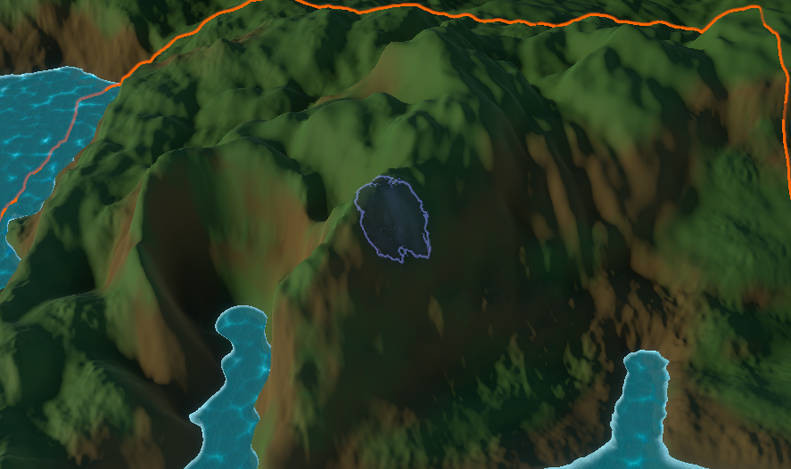

Creating the water shader:

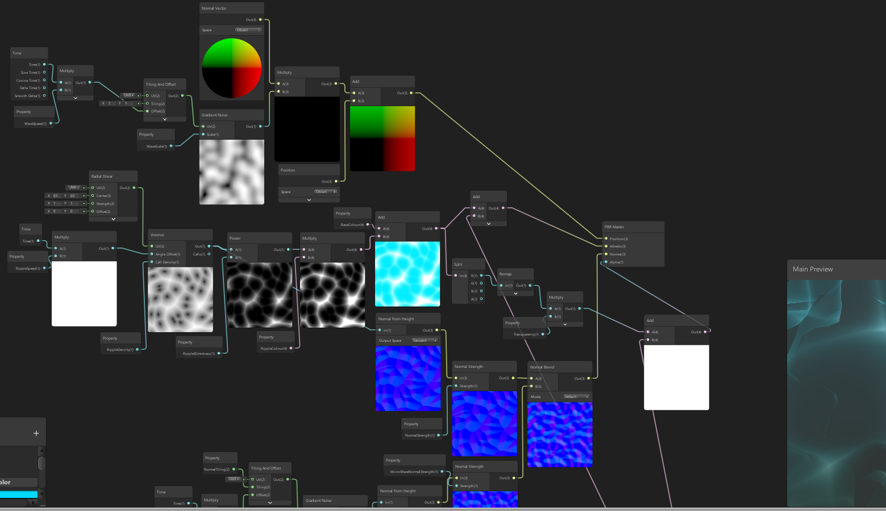

Programming the AI cover system:

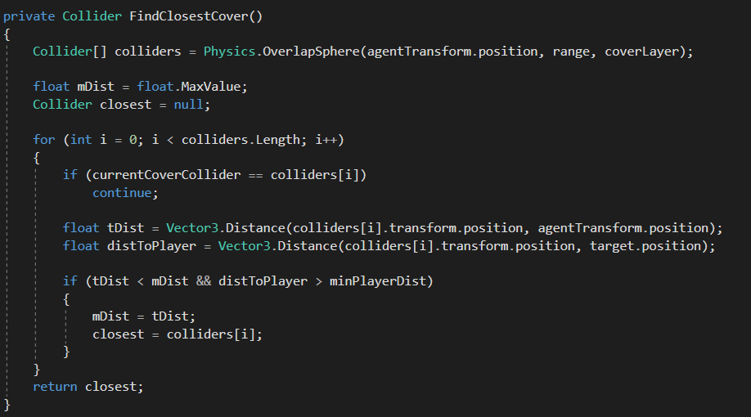

Programming the mission:

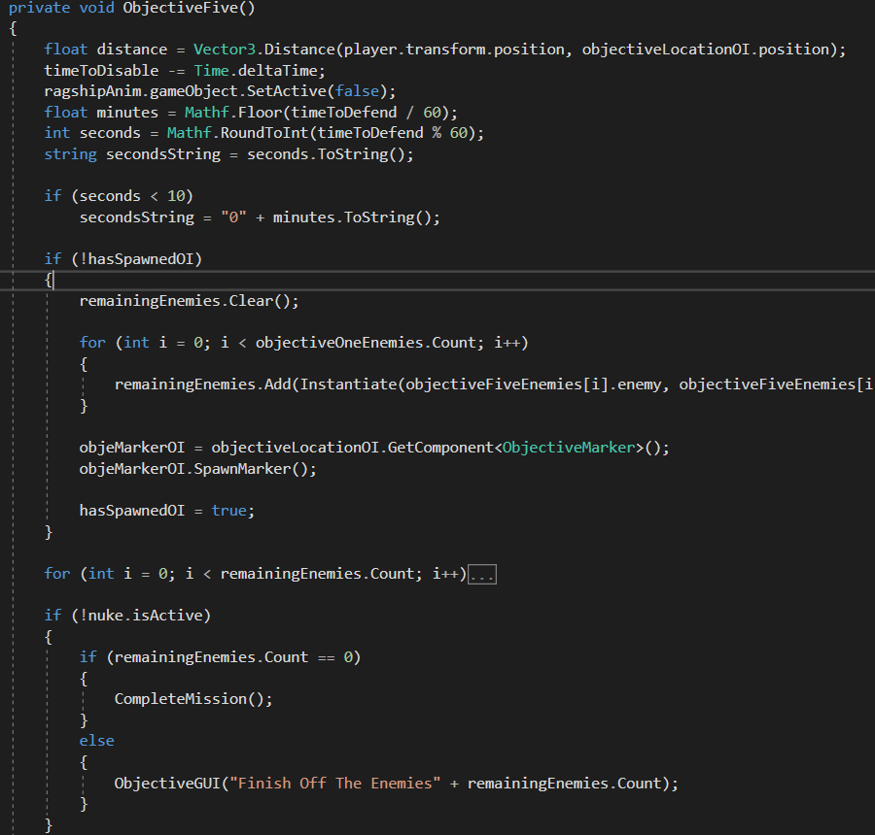

3D modelling some armour:

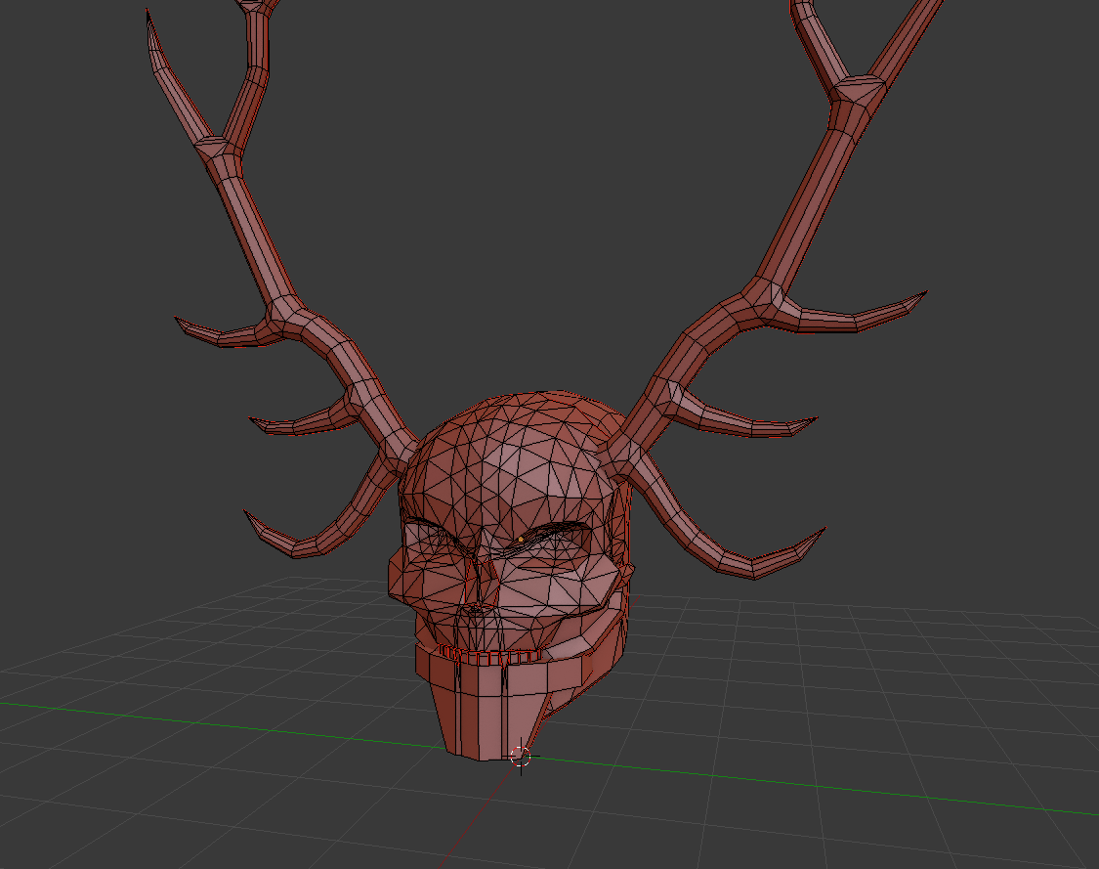

Texturing a weapon:

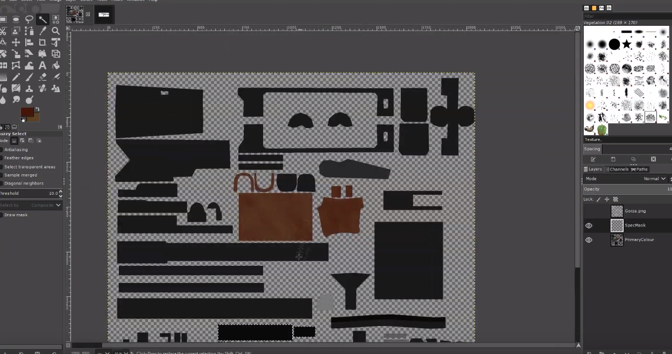

**Quality Control:**